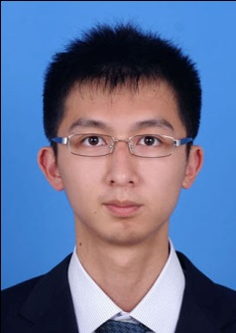**Personal Resume**

**Personal Basic Information**

**Name:** Wu Tung **Gender:** Male

**Education:**

2011/09 – 2014/03 : Shanghai Jiao Tong University | Software Engineering | Graduate.

2007/09–2011/07: SUNYAT-SEN University | Software Engineering | Undergraduate

**Phone:** 13818948621 **E-MAIL:** skwwt@163.com

**GPA and Awards**

* GPA: Graduate: **2.69 (top 10%)**; Undergraduate:: **3.61（top 10%）**. **CET6/CET4**.
* 2011/11: Second-class scholarship of Shanghai Jiao Tong University. | College level.
* 2008、2009: Second-class scholarship of SUNYAT-SEN University. | College level.
* 2009/05: Award in ACM Programming Contest of Guangdong Province | provincial level.
* 2009/04、2010/04：: Second Prize in ACM Programming Contest | College level.
* 2008/11: Third Prize in Software Innovation Competition | College level.
* 2008: Minister in E-business department of Information Technology Development Center.

**Project Experience**

** 2012/08 – now：PRECISE Java automatically parameter-recommended tool**

* PRECISE is a parameter automatically recommended tool based on Eclipse platform. It could provide precise message of parameters through learning the sample codes.
* Responsible for the development and testing of the code.

**  2010/05 -- 2010/10： Research about the digitization of safe agricultural production supply and the development of agricultural information service platform**

* The project of **agricultural information service platform has been selected to enter the first preparatory project library of the “12th Five” rural areas science and technology plan by the Ministry of Science and Technology.**
* Act as the leader of quality traceability group and responsible for the architecture design.

** 2009/01 --06: Application Management System for Students of SUNYAT-SEN University**

** 2010/01 -- 2010/04：UBOSS Travel Platform**

** 2010/10 -- 2010/11: “MapSpider” application software for Android mobilephone**

** 2009/7 -- 2009/8: Update of the Electronic platform in MeiJiang of MeiZhou City**

**Professional skills**

* Rich experience of **eclipse plugin** programming and good command of **SWT**.
* Proficient at **asp.net, J2EE, css**, and **JavaScript**.
* Strong ability to **algorithm design**.

**Self-assessment**

* Strong team spirit and excellent communication skills.
* Strong ability to learn new things. I learn JSP within two weeks and complete update of Agricultural Electronic Platform in MeiJiang District.